

THE INTERNATIONAL SCHOOL BANGALORE
ENTRANCE ASSESSMENT

SUBJECT: CHEMISTRY

GRADE: 11

TOTAL MARKS: 25 MARKS

TIME ALLOWED: 30 MINUTES

TEST DATE:

APPLICANT’SNAME:

INSTRUCTIONS:
- No Calculators are allowed.
- All questions are compulsory, please use a pen.
- Please circle only one correct answer from the given options.
- Please write your answers on the space provided on the question paper.
- Return the question papers and the rough sheets to the invigilator before leaving the hall.
This Question Paper consists of (6) printed pages including this cover page.

1. Impurities change the melting and boiling points of substances. Sodium chloride is added to a sample of pure water. How does the addition of sodium chloride affect the melting point and boiling point of the water?
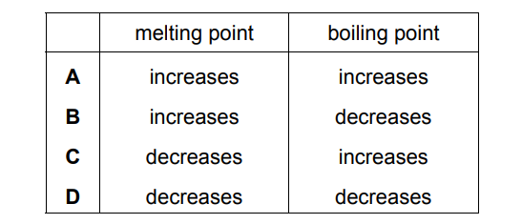
2. Which chromatogram shows how the Rf value of a substance is calculated?
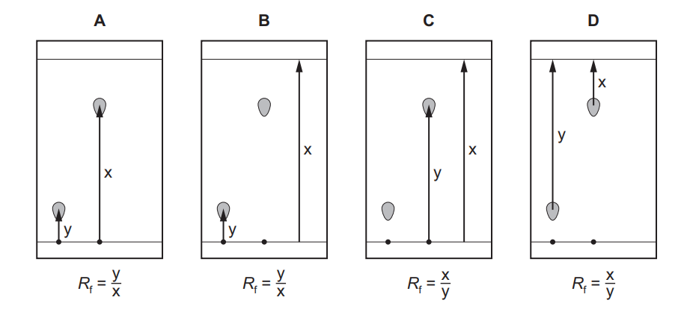
3. Which statement describes metallic bonding?
A The attraction between a lattice of negative ions and delocalised protons.
B The attraction between a lattice of positive ions and delocalised electrons.
C The attraction between delocalised protons and electrons.
D The attraction between oppositely charged ions.

4. Calcium carbide, CaC₂, reacts with water to form ethyne, C₂H₂, and calcium hydroxide. The equation for the reaction is shown.
CaC₂(s) + 2H₂O(l) → C₂H₂(g) + Ca(OH)₂(s)
Which volume of ethyne is produced when 6 g of water react completely with calcium carbide?
A 4 dm³
B 8 dm³
C 36 dm³
D 72 dm³
5. Nitrogen forms a nitride ion with the formula N^{3–}. Which particle does not have the same electronic configuration as the nitride ion?
A Al ³⁺ B Cl – C Na⁺ D O^{2–}

6. Which statement about electrolysis is correct?
A Electrons move through the electrolyte from the cathode to the anode.
B Electrons move towards the cathode in the external circuit.
C Negative ions move towards the anode in the external circuit.
D Positive ions move through the electrolyte towards the anode during electrolysis.

7. Which statement about fuels is correct?
A Heat energy can only be produced by burning fuels.
B Hydrogen is used as a fuel although it is difficult to store.
C Methane is a good fuel because it produces only water when burned.
D Uranium is burned in air to produce energy.

8. An example of a redox reaction is shown.
Zn + Cu²⁺ → Zn²⁺ + Cu
Which statement about the reaction is correct?
A Zn is the oxidising agent and it oxidises Cu²⁺.
B Zn is the oxidising agent and it reduces Cu²⁺.
C Zn is the reducing agent and it oxidises Cu²⁺.
D Zn is the reducing agent and it reduces Cu²⁺.

9. Which statements about the trends across a period of the Periodic Table are correct?
1 Aluminium is more metallic than sodium.
2 Beryllium is more metallic than carbon.
3 Boron is more metallic than lithium.
4 Magnesium is more metallic than silicon.

A 1 and 2 B 1 and 3 C 2 and 4 D 3 and 4

10. The fractional distillation of petroleum is shown. Which fraction contains hydrocarbons with the longest chain length?
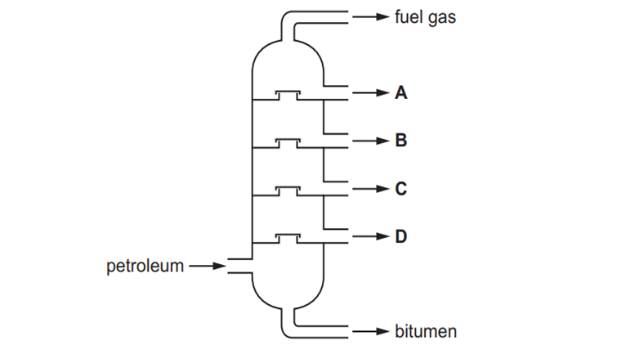

11. Nitrogen, hydrogen and ammonia gases are placed inside a container. The container is then sealed. After some time, an equilibrium forms.
N₂(g) + 3H₂(g) ↔2NH₃(g)
Which statement describes the equilibrium in this container?
A The amount of ammonia remains constant from the moment the container is sealed.
B The amounts of ammonia, nitrogen and hydrogen in the container are always equal.
C The rate of formation of ammonia is equal to the rate of decomposition of ammonia.
D The rate of formation of ammonia is faster than the rate of decomposition of ammonia.
12. In reaction R, 2000 molecules of CH₂=CH₂ react to form a single molecule X only.
2000 CH₂=CH₂ → X
Which terms describe reaction R, CH₂=CH₂ and X
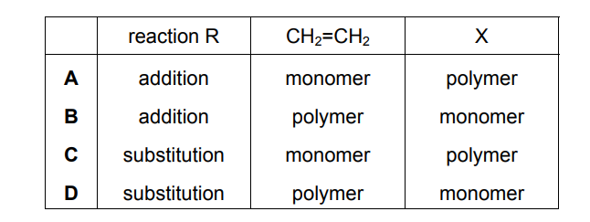
13. The concentration of acids and alkalis can be determined by titration.
Which pieces of equipment are needed to perform a titration?
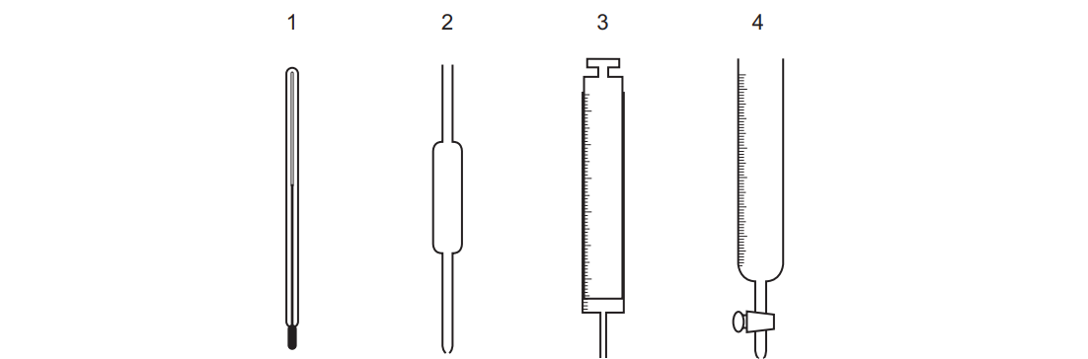
A 1 and 2 B 1 and 3 C 2 and 3 D 2 and 4

14. The structural formulae of two hydrocarbons are shown.
CH₃CH₂CH₂CH₃ CH₃CH(CH₃)CH₃
Which statement about the hydrocarbons is correct?
A They are both alkenes.
B They decolourise aqueous bromine.
C They are structural isomers.
D They undergo addition reactions.

15. Why are weather balloons sometimes filled with helium rather than hydrogen?
A Helium is found in air.
B Helium is less dense than hydrogen.
C Helium is more dense than hydrogen.
D Helium is unreactive.

